ASE CSIE – Economic Informatics Year 3 Supplementary
Almășanu Iany Ionuț
Design of Informatics Systems 2025-2026
Virtual Studio Technology (VST) Programming

The scope of this project is to detail the design of a VST plugin used to produce and alter sounds.
VSTs integrate virtual instruments (VSTi) and effects (VSTfx) into Digital Audio Workstations (DAWs). For Windows OS, the VSTs are usually coded in C++ and compiled in a single “.vst3” file which is manually loaded into a DAW to be used in producing music in a digital environment.
The VST responds to user’s input, transforming MIDI input (Musical Instrument Digital Interface) into high-fidelity audio.
The program is built around three signal generators called oscillators. Each oscillator has its own properties which can be adjusted by tweaking specific controls (knobs, buttons, sliders, etc.).
The shape of each oscillator can be set by the user to generate Sinewave, Sawtooth, Square or Triangle waveforms, and all three can be merged into a unique sound. Each oscillator can have its shape altered further, by modifying its ASDR Envelope (Attack, Decay, Sustain, Release).
As for effects, the output signal generated by the oscillator can be individually modified with simple effects such as Reverb, Delay, and EQ (equalizer).
The user interface will be easy to understand and practical. It will be split into three identical parts, each with its own buttons, knobs and sliders.
The scope of developing such an instrument is to create a way to make music production a bit easier, as the current alternatives on the market may be seen as too complex, especially for beginners.

General use case diagram
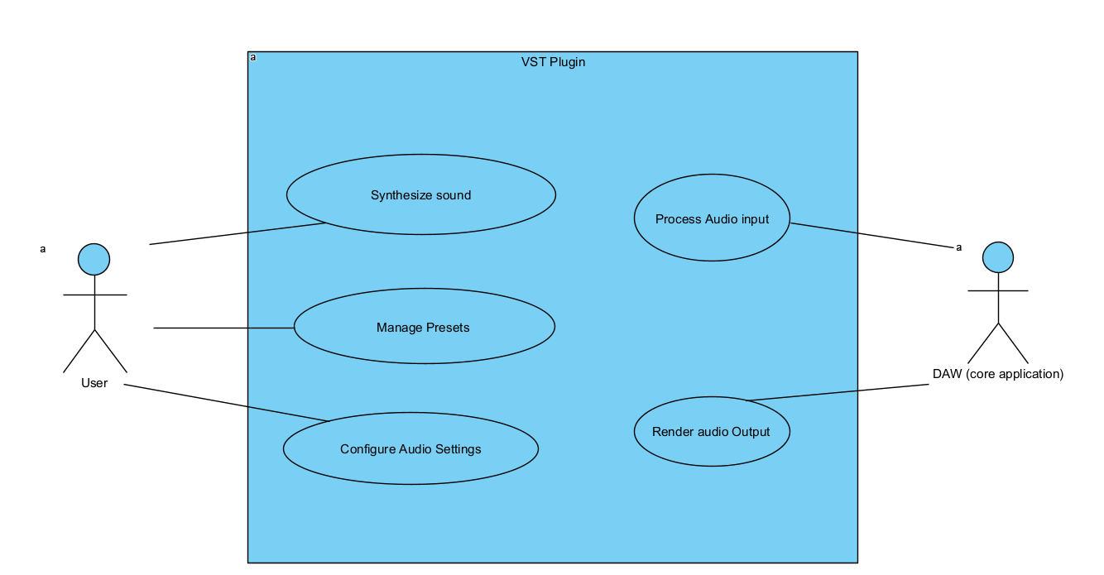
Detailed use case diagram
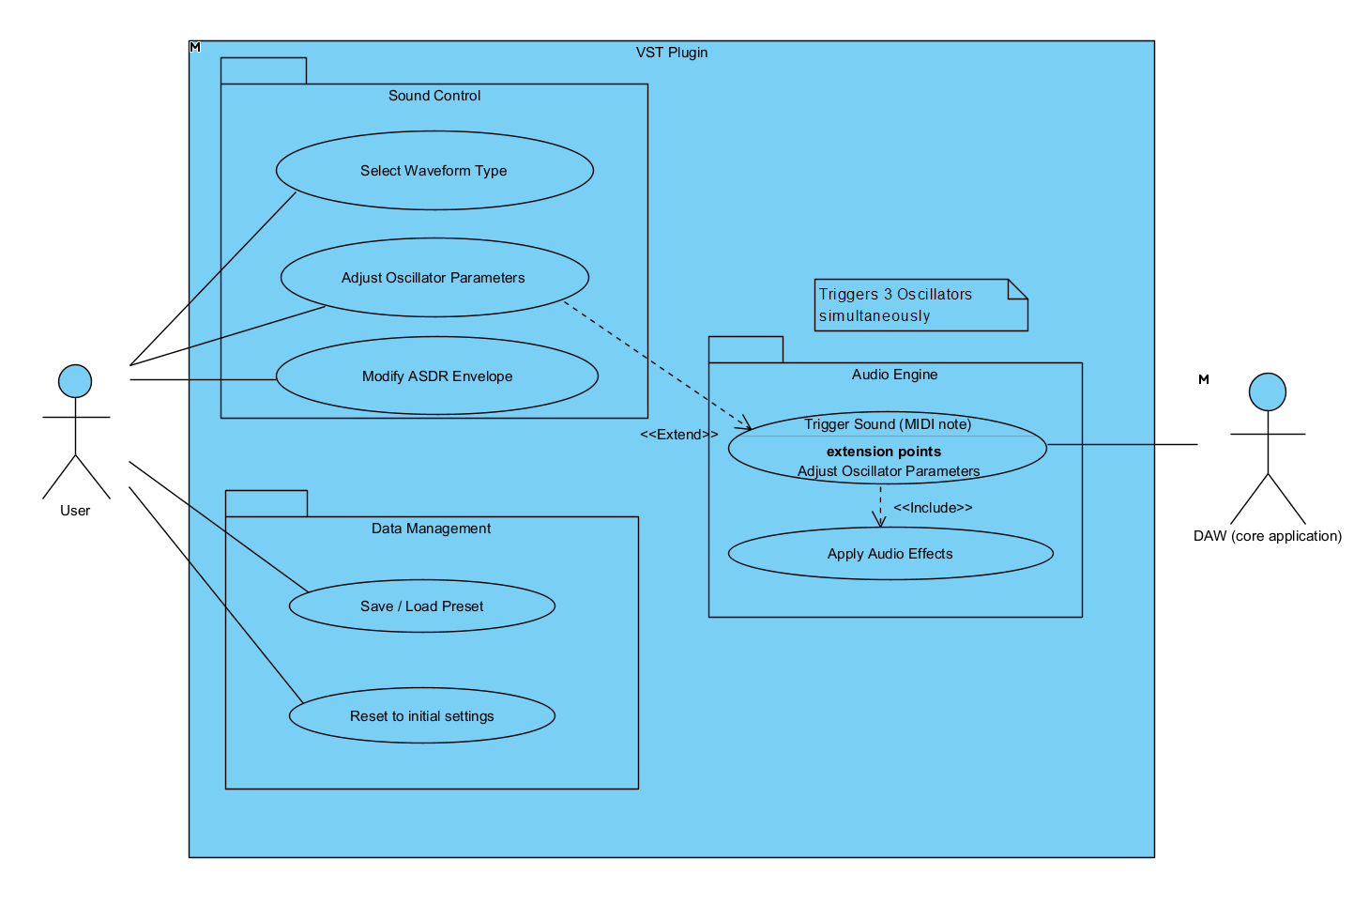
The Use Case diagrams illustrate the primary interactions between the User and the Synthesizer System. Key actions include 'Trigger Note', 'Modify Oscillator Parameters', and 'Save/Load Preset'. These represent the functional boundaries of the software.

Textual description of use cases for each diagram:
- General use case diagram:
- Synthesize sound
- Manage Presets
- Configure Audio Settings
- Process Audio Input
- Render Audio Output
- Detailed use case diagram:
- Sound Control
  - Select Waveform Type
  - Adjust Oscillator Parameters
  - Modify ASDR Envelope
- Data Management
  - Save/Load Preset
  - Reset to initial settings
- Audio Engine
  - Trigger Sound (MIDI Note)
  - Apply Audio Effects

Activity Diagrams - These diagrams map the procedural flow of the system. Specifically, the 'Sound Synthesis' activity shows the signal path from MIDI input to audio output, while the 'Preset Management' activity details the validation steps required when saving data to the disk.

Activity Diagram 1 – The “Note On” Logic
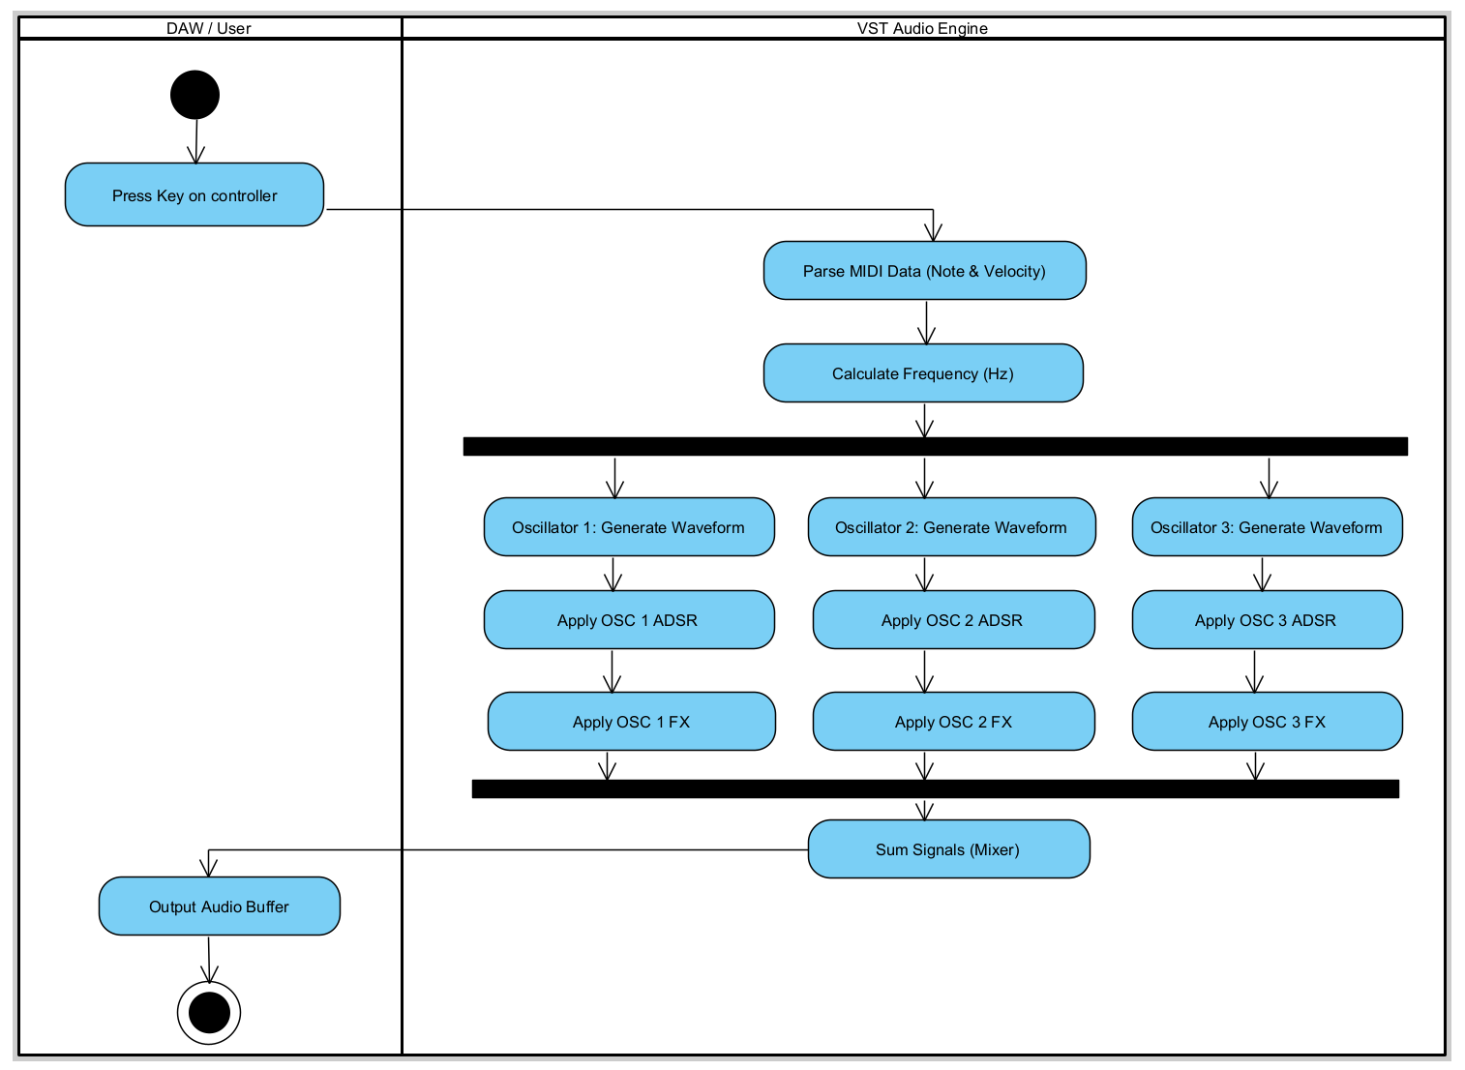

Activity Diagram 2 – Preset Saving Process
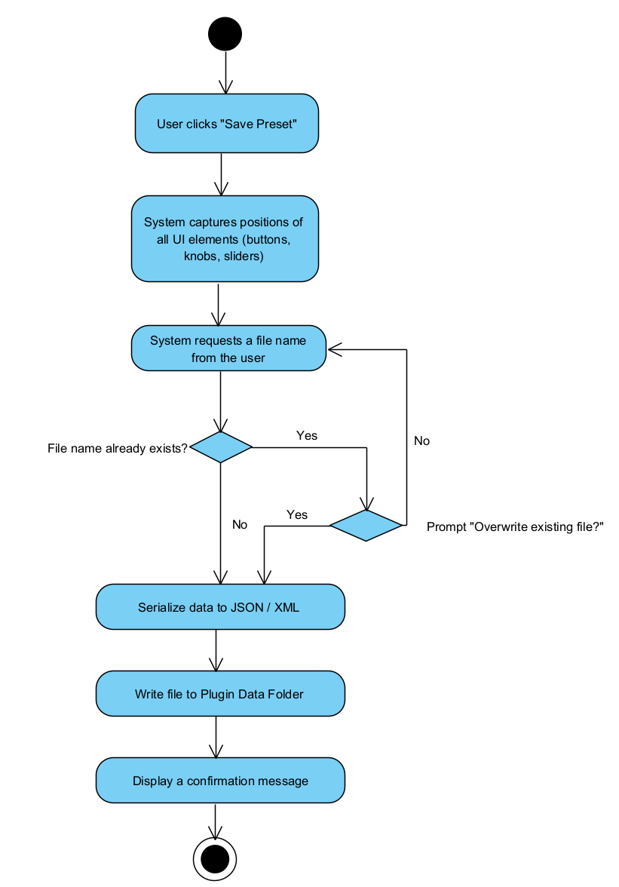
Activity Diagram 3 – Real-time Parameter Change
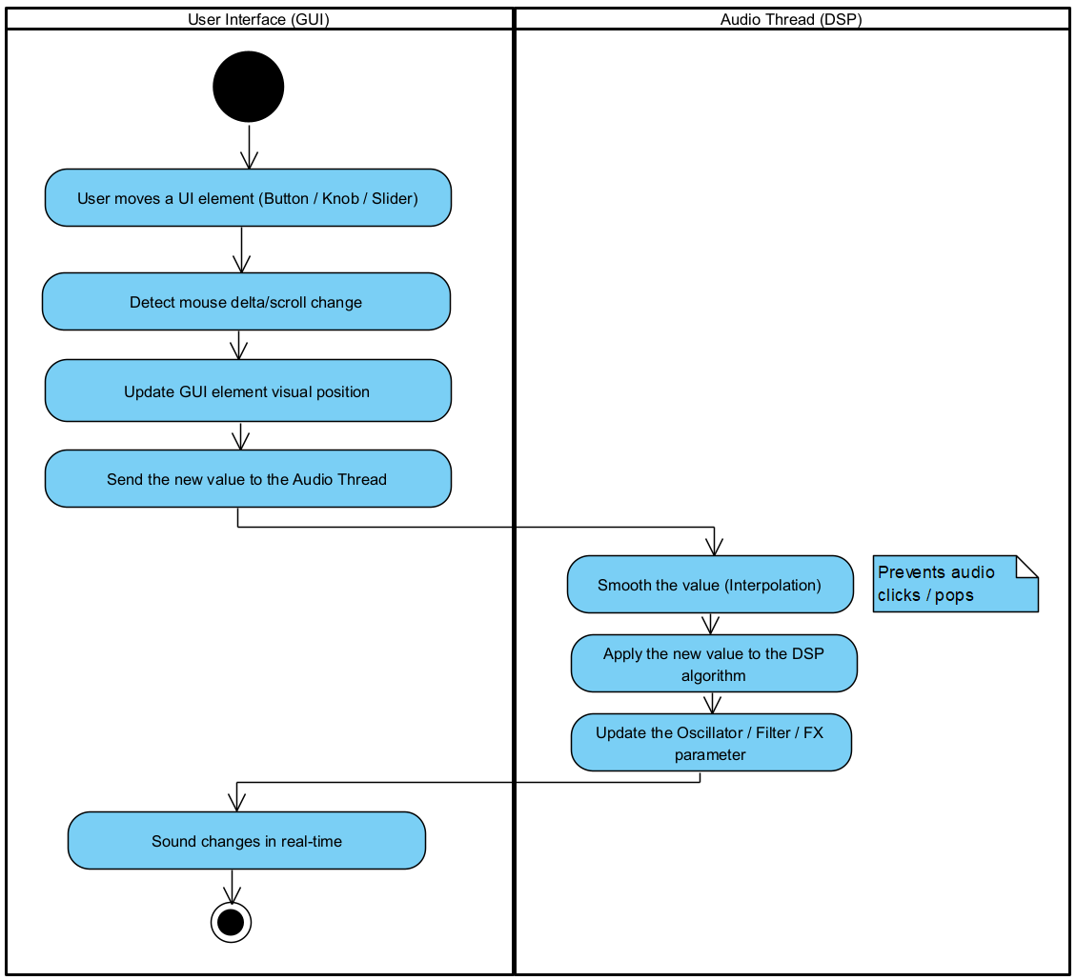

Simple Class diagram – VST Synthesizer (Analysis)
The analysis class diagram identifies the core domain entities: the Oscillator, PluginProcessor, and Effect. This high-level view establishes relationships and cardinalities (e.g., one Processor contains three Oscillators) without focusing on implementation details.
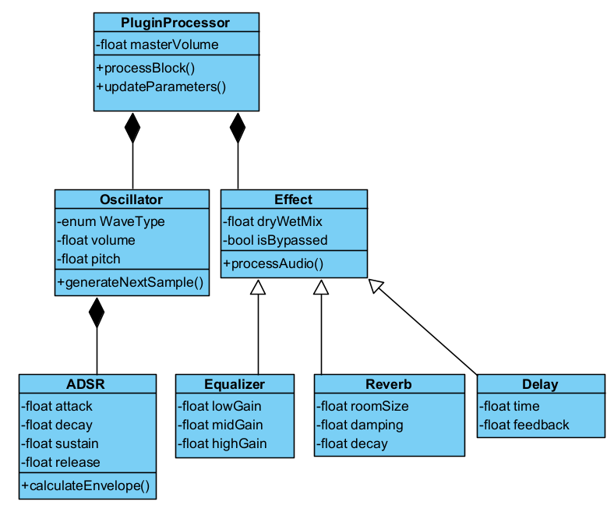

The state diagrams track the lifecycle of the Voice (Idle, Attack, Decay, Sustain, Release) and the Global Plugin State. This ensures the system handles transitions—like stopping audio when a note is released—without logic errors.
State Machine Diagram 1 – Oscillator Operational Status
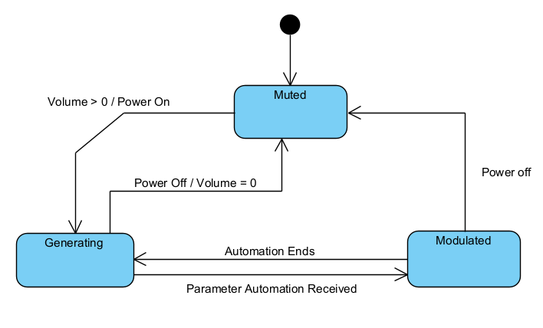
State Machine Diagram 2 - ADSR Envelope Lifecycle
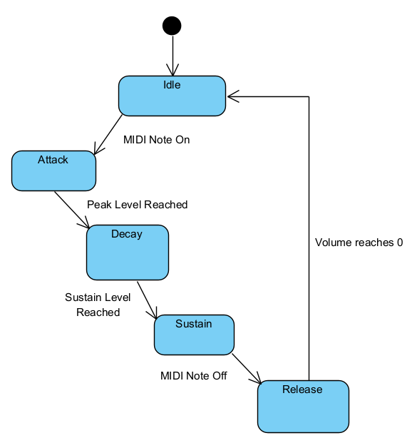
The Sequence diagrams model the time-ordered exchange of messages between the GUI and the DSP engine. The Communication diagram highlights the structural organization of objects involved in the Effects processing chain.
Sequence Diagram 1 – Loading a Preset
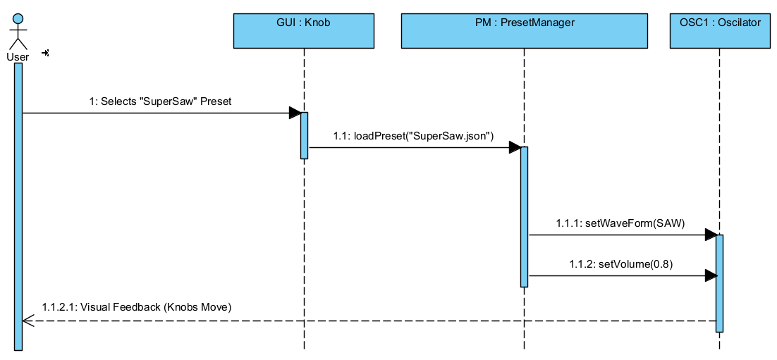
Sequence Diagram 2 – Note Trigger to Audio Output
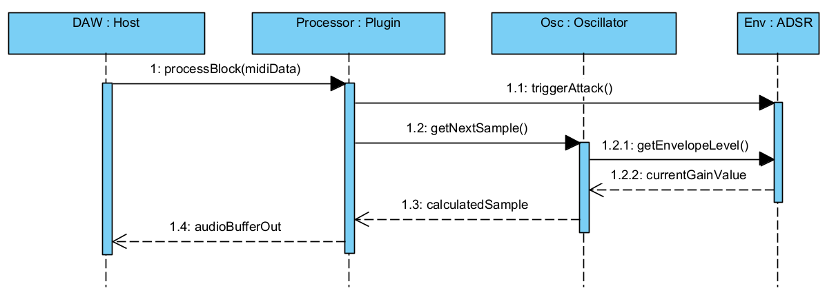

Communication diagram: Parameter Update
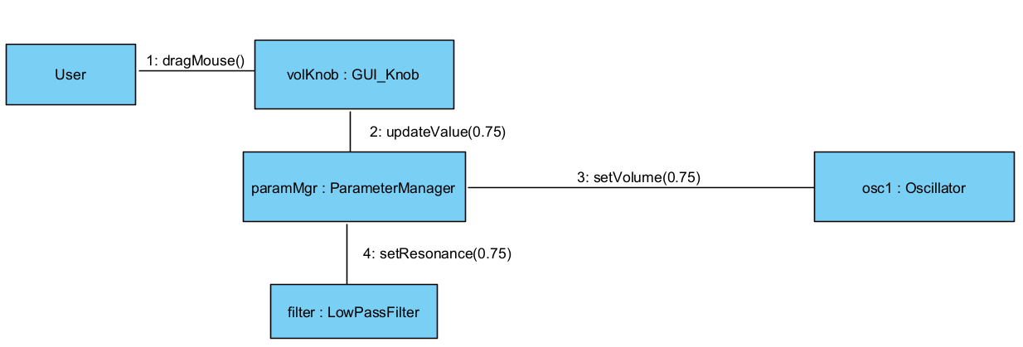
BPMN – Process diagram: Waveform Update Logic
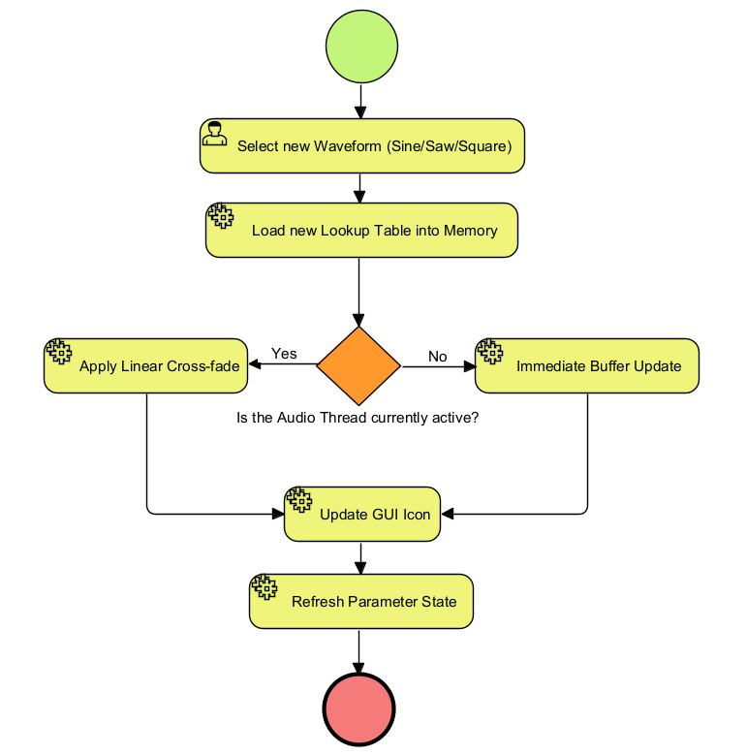

The Process diagram details the internal logic of the waveform update cycle. The Collaboration diagram shows the high-level orchestration between the User, the DAW Host, and the VST Plugin, utilizing message flows to represent cross-boundary communication.
BPMN – Collaboration diagram:
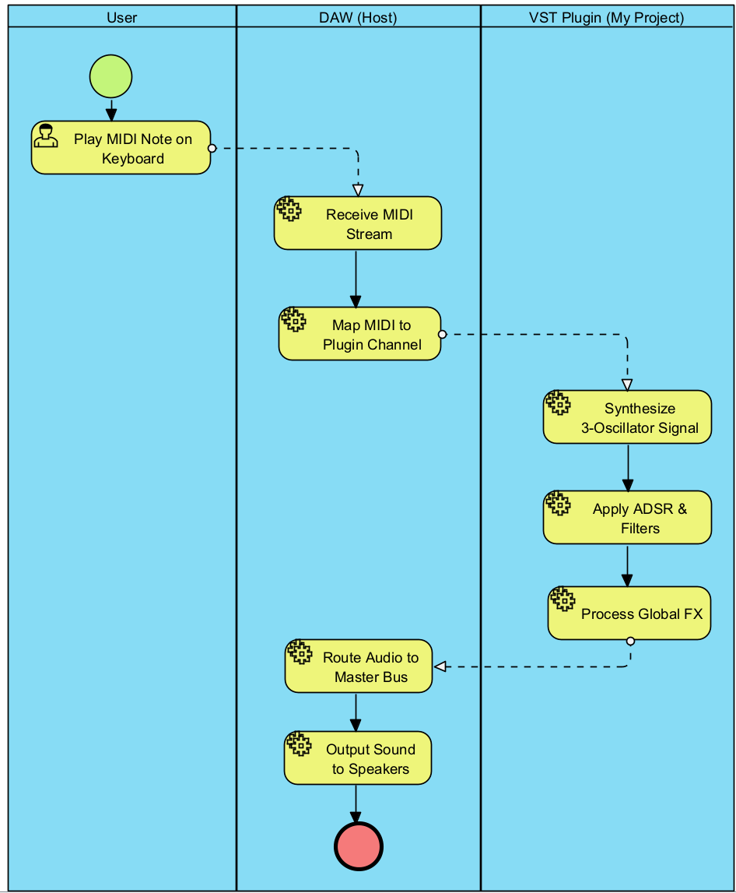
Detailed Class Diagram - This design-level diagram adds technical specifications, including private member variables, public method signatures, and data types (float, double, bool). It serves as the blueprint for the C++ implementation phase.
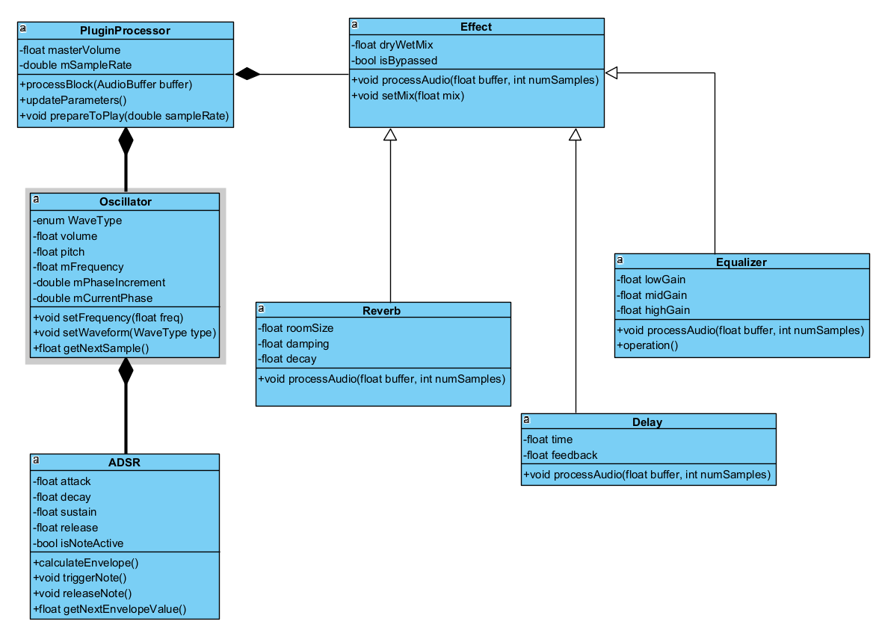

The ER diagram defines the relational structure for the preset library. It ensures that user-created sounds are correctly associated with categories and metadata, allowing for efficient SQL-based querying and retrieval.
Relational Database Diagram:
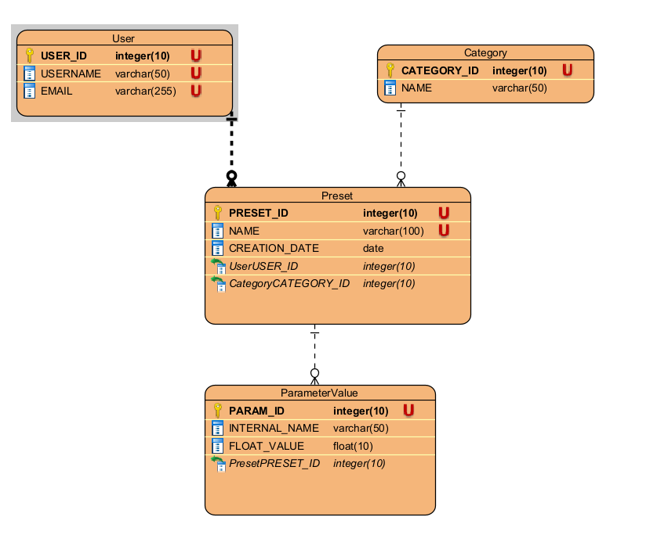

This Mockup design is designed to be easy to read. Of course this is just a simple version, with everything “on the table”, however the final product will be more modernly styled.

Mockup design:
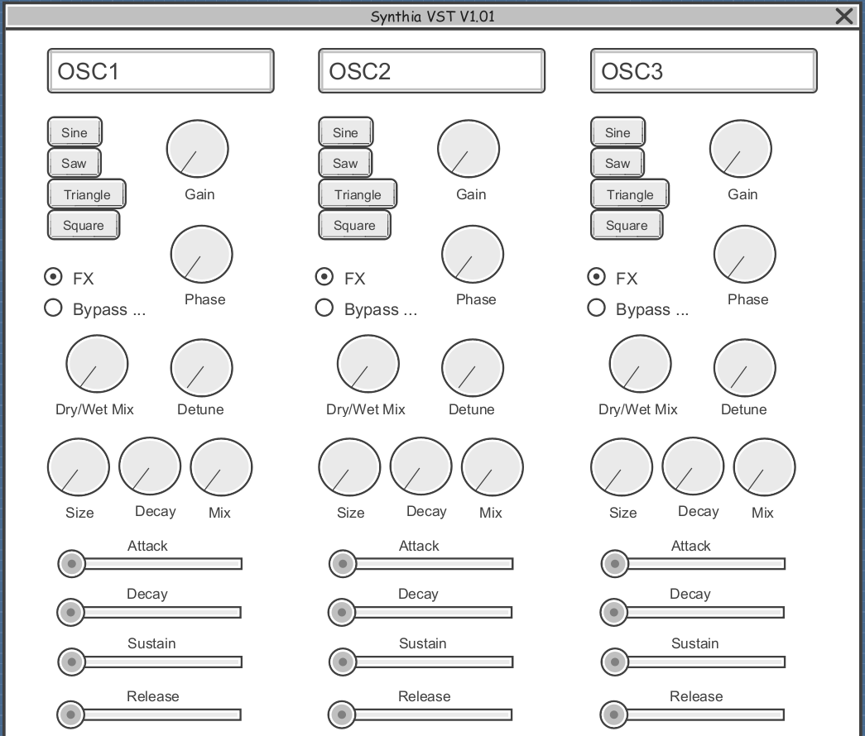

The component diagram illustrates the system architecture, dividing the software into three distinct modules: GUI, DSP Engine, and Preset Manager. This modularity allows for independent updates to the interface or the audio code.

Component diagram
